**Program Seven Part One:**

//summary: takes in a number of students, makes an array, and takes in grades for each student. it then finds the best grade,

// and gives each student a letter grade based on the best students grade

//name: Jenna Wolf

//class: Fundamentals of Programming, CS155 - 01

//instructor: Dr. Art Kazmierczak

//date: 10/01/2023

import java.util.Scanner; //allows inputs to be made

public class Main

{

public static void main(String[] args)

{

Scanner input = new Scanner(System.in); //labels input as input

int numStudent; //holds the numStudent data

double best; //holds the best data

//takes in the number of students

System.out.print("Enter the number of students: ");

numStudent = input.nextInt();

Double[] studentGrade = new Double[numStudent]; //makes an array of size numStudent

//takes in the grades of each student and makes sure it is between 0 and 100

System.out.print("Enter the grades of each student (put a space between each grade): ");

for(int i = 0; i < numStudent; i++)

{

studentGrade[i] = input.nextDouble();

if(studentGrade[i] > 100 || studentGrade[i] <= 0)

{

System.out.print("Please enter a proper grade: ");

studentGrade[i] = input.nextDouble();

}

}

//sets best to the first grade and then goes through all grades and sees which one is actually the best

best = studentGrade[0];

for(int i = 1; i < numStudent; i++)

{

if(studentGrade[i] > best)

best = studentGrade[i];

}

//displays the students number grade along with there alphabetical grade

for(int i = 0; i < numStudent; i++)

{

if(studentGrade[i] >= best - 10)

System.out.println("Student " +( i + 1) + " has a score of " + studentGrade[i] + " which is a A");

else if(studentGrade[i] >= best - 20)

System.out.println("Student " + (i + 1) + " has a score of " + studentGrade[i] + " which is a B");

else if(studentGrade[i] >= best - 30)

System.out.println("Student " + (i + 1) + " has a score of " + studentGrade[i] + " which is a C");

else if(studentGrade[i] >= best - 40)

System.out.println("Student " + (i + 1) + " has a score of " + studentGrade[i] + " which is a D");

else

System.out.println("Student " + (i + 1) + " has a score of " + studentGrade[i] + " which is a F");

}

}

}

Output:

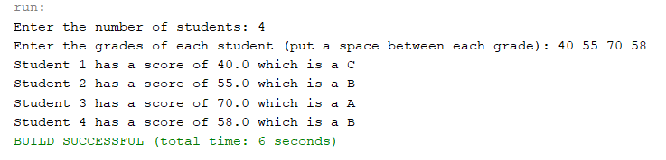

**Program Seven Part Two:**

//summary: This program takes in an array of ten numbers and prints out the reversed order

//name: Jenna Wolf

//class: Fundamentals of Programming, CS155 - 01

//instructor: Dr. Art Kazmierczak

//date: 10/01/2023

import java.util.Scanner; //allows inputs to be made

public class Main

{

public static void main(String[] args)

{

Scanner input = new Scanner(System.in); //labels input as input

int[] numbers = new int[10]; //holds the number data (is an array of size 10)

//takes in the ten numbers from the user

System.out.print("Enter ten integers, with a space between each: ");

for(int i = 0; i < 10; i++)

numbers[i] = input.nextInt();

//prints out the numbers in reverse order

System.out.println("Numbers in reverse order:");

for(int i = 0; i < 10; i++)

System.out.print(numbers[10 - i - 1] + " ");

}

}

Output:

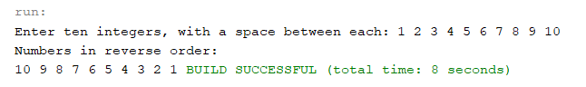

**Program Seven Part Three:**

//summary: takes in 10 numbers from the user into an array and goes to the min method to find the smallest number

//name: Jenna Wolf

//class: Fundamentals of Programming, CS155 - 01

//instructor: Dr. Art Kazmierczak

//date: 10/01/2023

import java.util.Scanner; //allows inputs to be made

public class Main

{

public static void main(String[] args)

{

Scanner input = new Scanner(System.in); //labels input as input

double[] numbers = new double[10]; //holds the numbers data (is an array of size 10)

//takes in 10 numbers from the user

System.out.print("Enter ten numbers, with a space between each: ");

for(int i = 0; i < 10; i++)

numbers[i] = input.nextDouble();

//calls the min method and outputs what is returned

System.out.println("The smallest number out of these ten numbers is " + min(numbers));

}

public static double min(double[] array)

{

double smallest = array[0]; //holds the smallest data and sets it to the first number in the array

//loop that sees if the current digit in the array is smaller than the current smallest. if yes, then

//sets said number to the smallest

for(int i = 1; i < 10; i++)

{

if(array[i] < smallest)

smallest = array[i];

}

return smallest; //returns the smallest data

}

}

Output:

